Microsoft is headquartered in Redmond, Washington. Bill Gates founded the company, which develops Windows and Office.
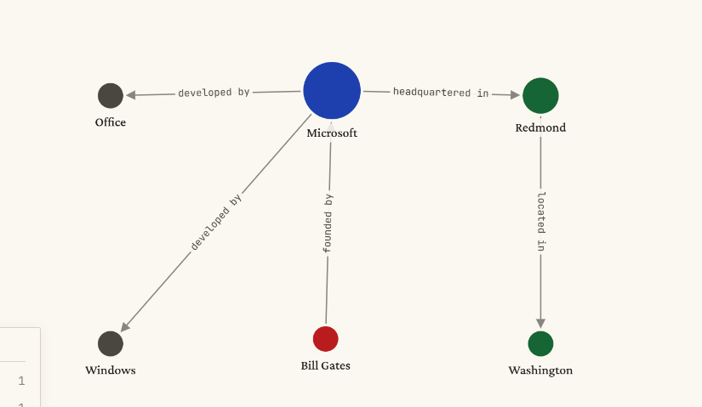

3 Specific Research Aims
The objectives of this research are organized as five aims, each building on the previous one.
Together they form a coherent path from baseline measurement to real-world validation:
1. Build a benchmark workload that can serve as a fair, repeatable test stage for
every measurement. Without a shared experimental basis, no meaningful comparison
between tracing tools is possible.
Success indicator: a working benchmark whose CPU and throughput measurements
are repeatable across runs.
2. Measure existing tracing tools on the benchmark to establish a quantitative
baseline of where the field stands today. Literature reports vary widely; a controlled
measurement on a single platform is needed to fix a reliable reference point.
Success indicator: a results table covering latency overhead, throughput drop, CPU
usage, and event capture rate for a representative set of existing tracing tools.
3. Build the proposed tracing SDK prototype, turning the hypothesized design
into working software that integrates the lock-free ring buffer, the sidecar analyzer,
and the overwrite-oldest buffer policy.
Success indicator: a functional SDK prototype that attaches to the benchmark and
writes trace events without locks and without system calls on the hot path.
4. Quantify the SDK’s overhead on the benchmark using the same measurement
procedure as Aim 2, providing a direct, side-by-side comparison with existing tools.
Success indicator: low overhead in latency and throughput together with a high event
capture rate, evaluated against the literature thresholds established in Aim 2.

Level 1
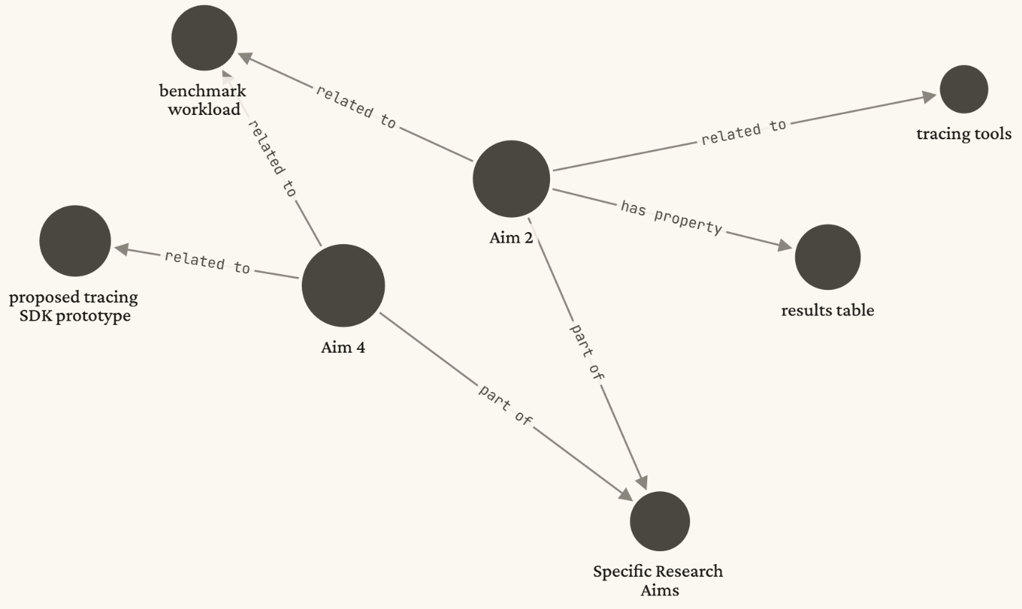
Level 2
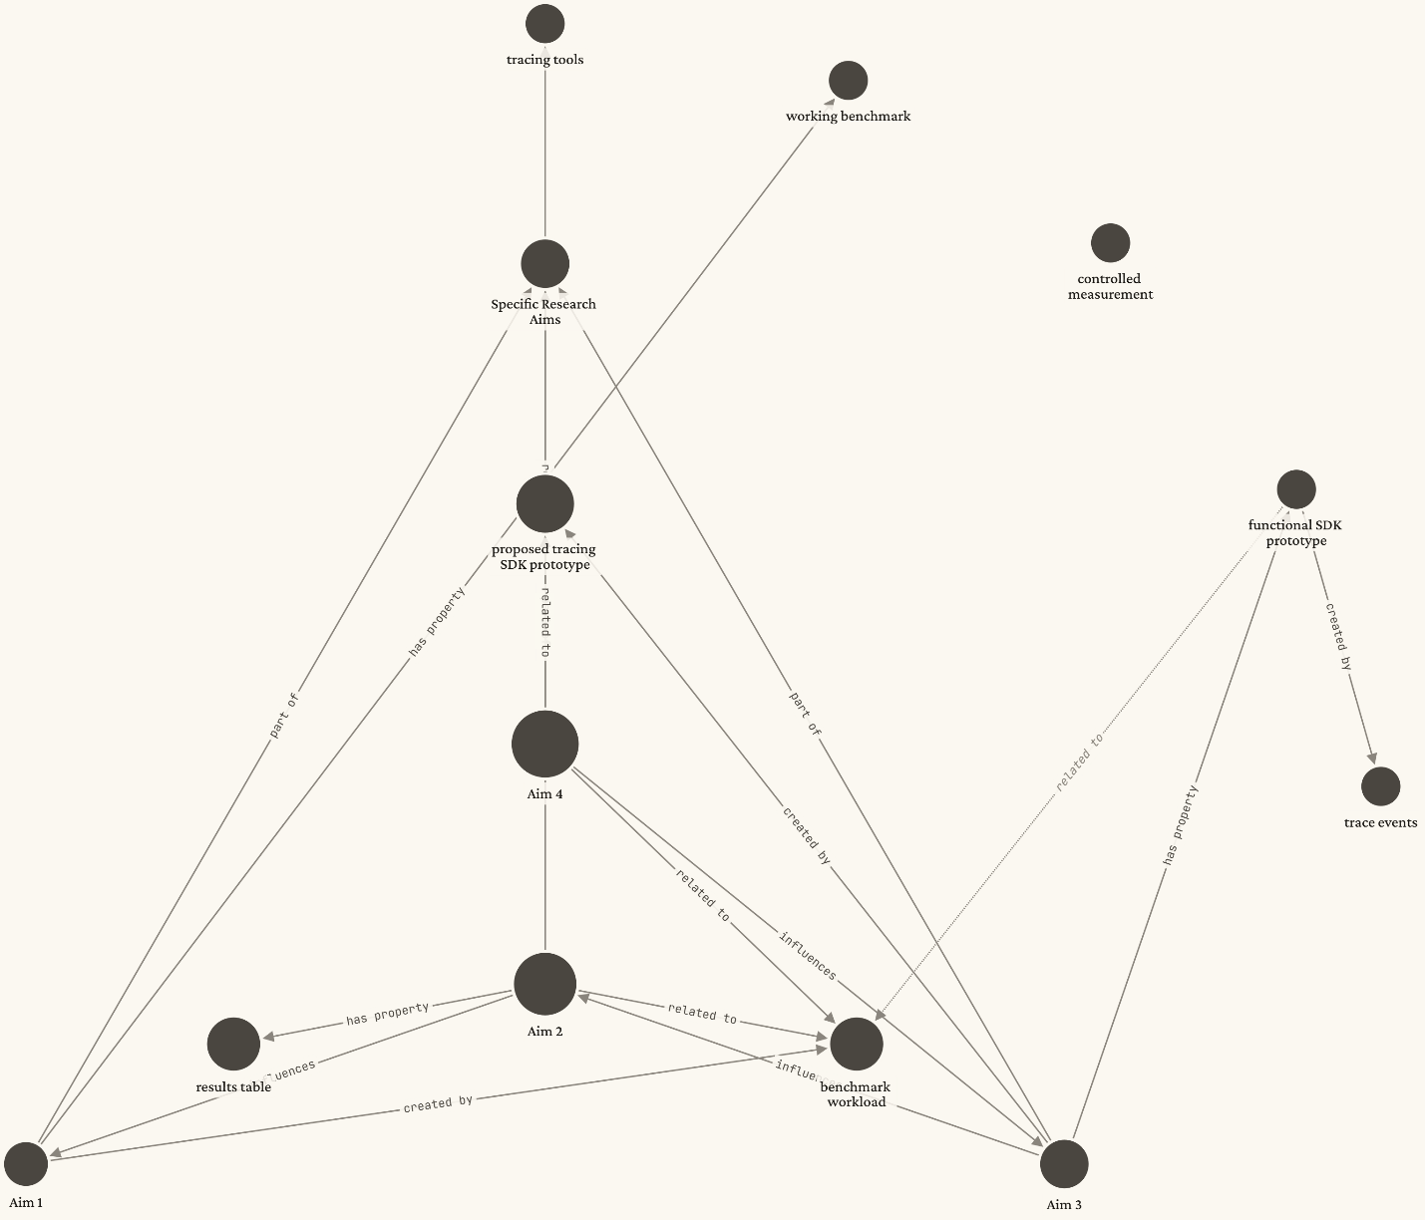

Level 7
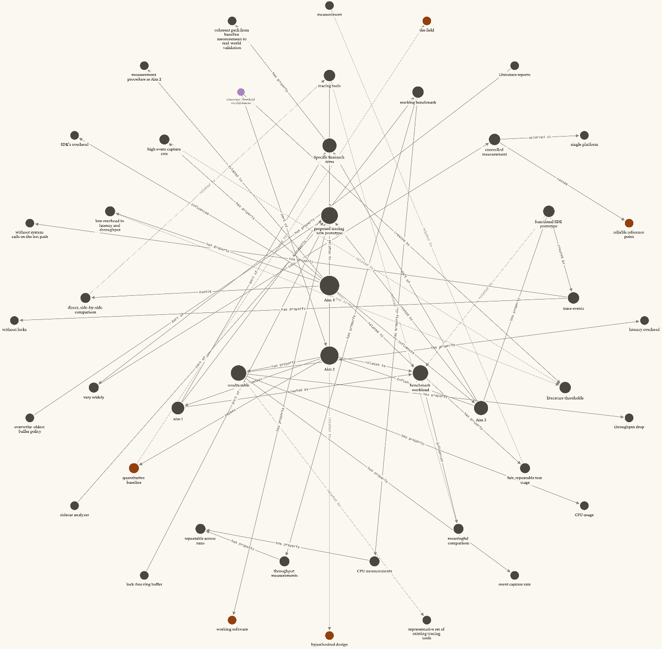

Mark Twain, born Samuel Clemens in Missouri, wrote The Adventures of Tom Sawyer and Adventures of Huckleberry Finn. He married Olivia Langdon in 1870, and the couple settled in Connecticut. Twain received an honorary doctorate from Oxford University in 1907.
level 3
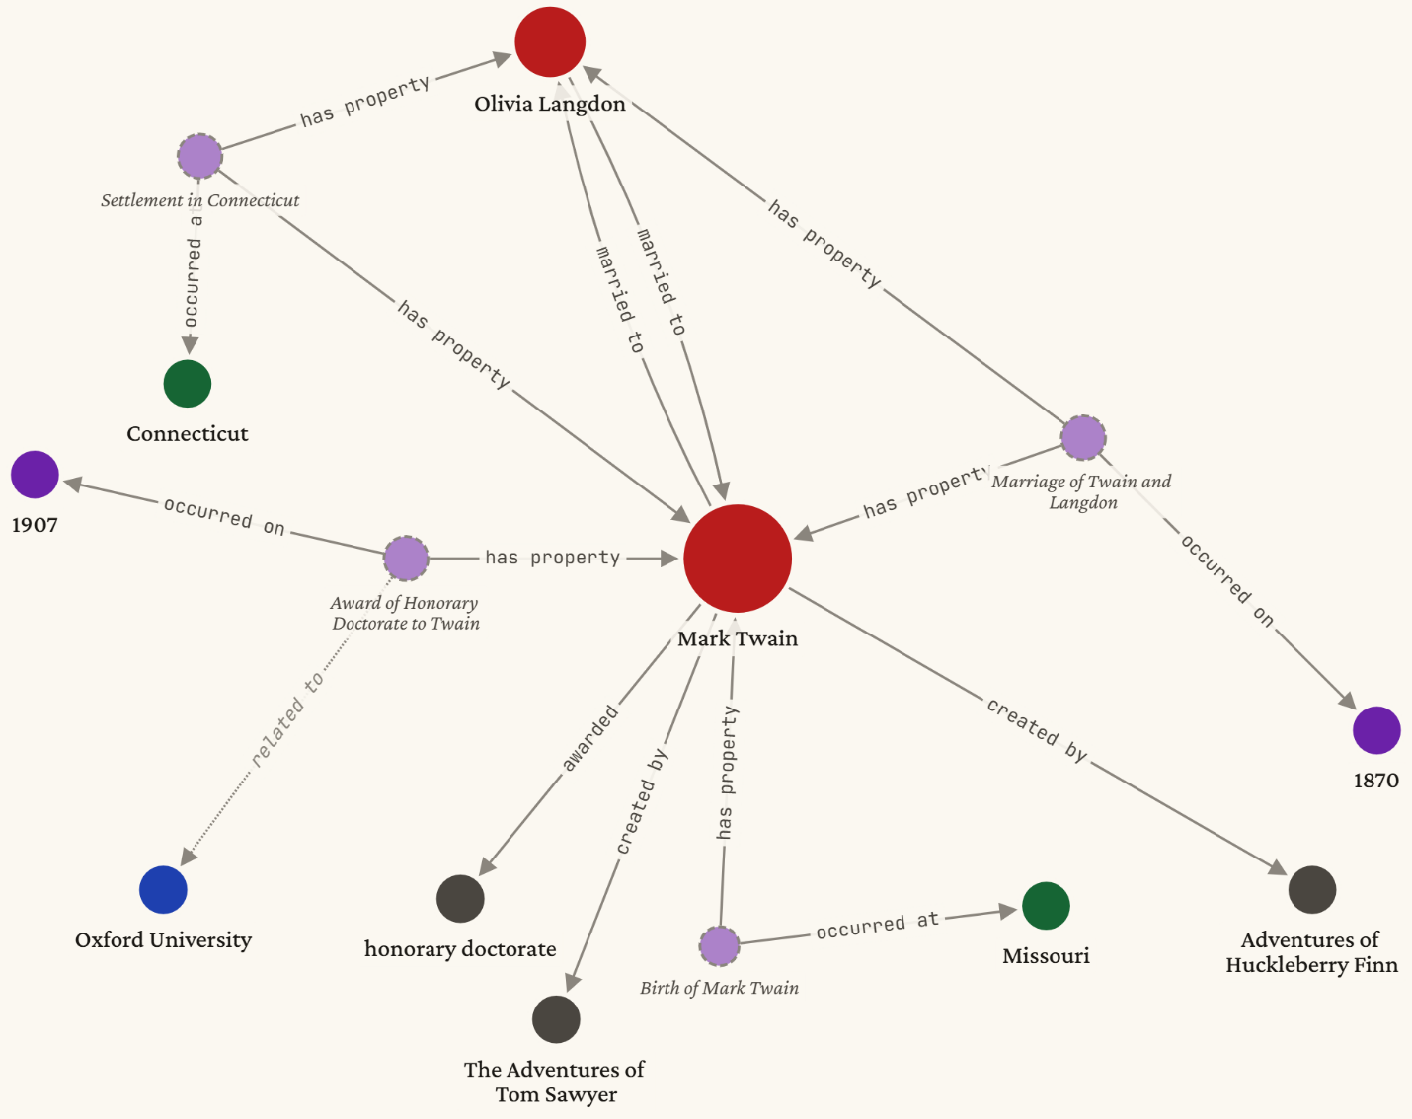
Level 1